**Analyzing the Performance & Efficiency of The Radisson Hotels using Data Visualization Techniques**

**Category:**Data analytics with IBM Cognos

**Team id:** LTVIP2023TMID06288

**Internship at:** SmartInternz

|  |  |
| --- | --- |
| **Team Lead** | Kuruva Rangaswamy |
| **Team Members** | M Suchitra |
| Kolla Deekshitha |
| K Sneha |
| V Gnaneshwari |

**Mail Id:** kuruvarangaswamy2003@gmail.com

**Table of Content**

1. Introduction 3

1.1 Overview 3

1.2 Purposes 3

2. Problem Definition & Design Thinking 3

2.1 Proposed Solution 4

2.2 Empathy Map 4

2.3 Ideation & Brainstorming Map 5

3. Result 6

3.1 Radisson Hospitality Analysis 6

3.2 Radisson Analysis Story 9

4. Advantages & Disadvantages 11

5. Applications 12

6. Observation 12

7. Conclusion 12

8. Future Scope 13

9. Appendix 13

9.1 IBM Cognos Public View 13

9.2 Source Code 14

# 

# 1. Introduction

## 1.1 Overview

The hotel industry is a vast and diverse sector that encompasses a wide range of businesses that provide lodging services to travelers and tourists. Radisson is a wellknown hospitality brand that owns multiple five-star hotels across India. However, due to strategic moves from other competitors and ineffective decision-making in management, Radisson is losing its market share and revenue in the luxury/business hotels category. In response, the managing director of Radisson has tasked us with creating an analytics dashboard and story to provide insights for better decisionmaking

## 1.2 Purposes

This project report aims to provide a comprehensive analysis of the hotel industry, with a focus on the luxury/business hotels category. The report will also explore the challenges faced by Radisson and the importance of incorporating Business and Data Intelligence to regain their market share and revenue.

The report will include a detailed description of the analytics dashboard and story that we created for Radisson, which will provide valuable insights for better decision-making. The report will also discuss the methodology used in developing the dashboard and story, including data sources, data cleaning, and data analysis techniques

# 2. Problem Definition & Design Thinking

Generally, if the given data set was to be analyzed in the old-fashioned methods, such as using geometrical instruments to draw the graphs on a piece paper, using scales & graph papers to plot the variation of the data fields, etc. The problem is to identify the key performance indicators (KPIs) and metrics to analyze the performance and efficiency of Radisson Hotels, compare performance across different hotels, identify patterns and trends over time, and create forecasting models for future performance. The social impact of this analysis includes improving the safety of customers, ensuring guest satisfaction, and promoting hygiene in food.

## 2.1 Proposed Solution

The proposed solution is to develop an analytics dashboard and story that will provide Radisson Hotels with insights to make better business decisions. The analysis will identify key performance indicators (KPIs) and metrics to analyze the performance and efficiency of Radisson Hotels, compare performance across different hotels, identify patterns and trends over time, and create forecasting models for future performance. A literature survey will be conducted to review existing literature and studies related to hotel performance and efficiency, identify best practices and strategies, and explore any unique challenges or opportunities specific to Radisson Hotels.

### 2.2 Empathy Map

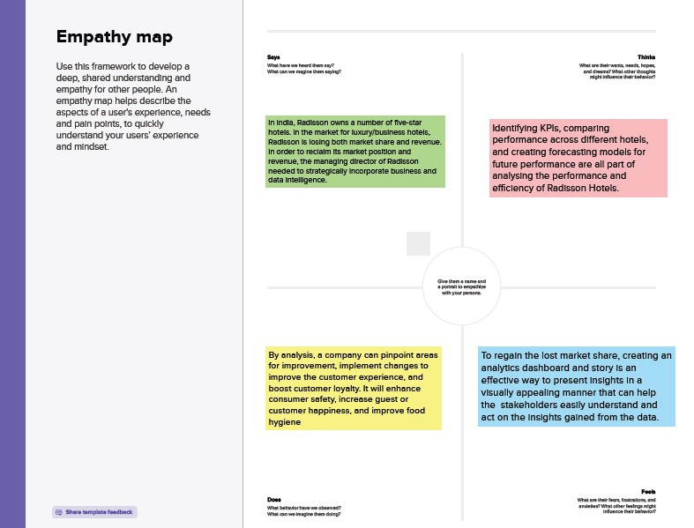

## 2.3 Ideation & Brainstorming Map

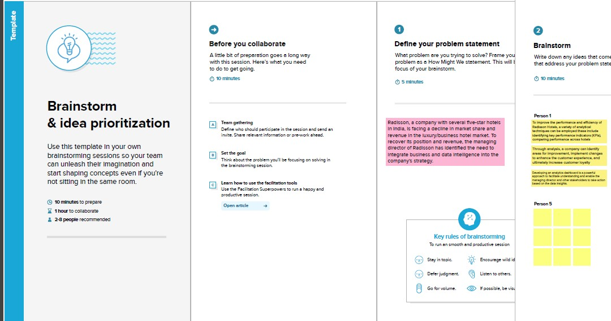

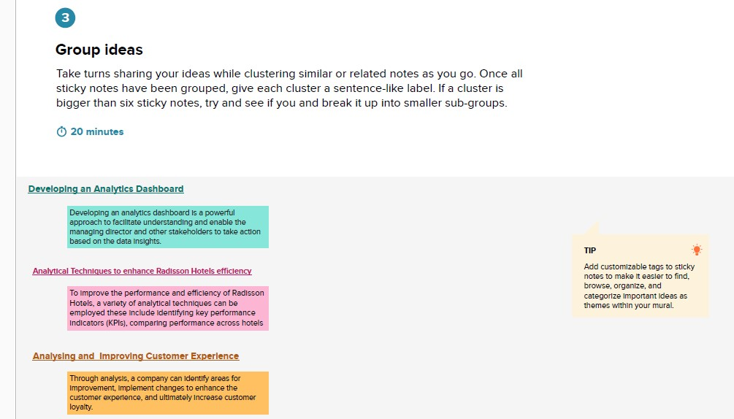

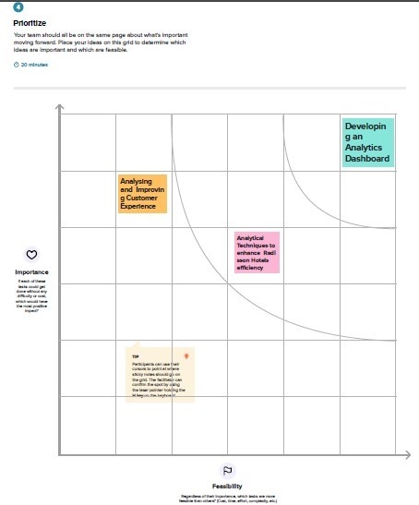

# 3. Result

## 3.1 Radisson Hospitality Analysis

A dashboard is a user interface that presents information and data in a well-organized and easily comprehensible format. They are commonly employed for real-time data monitoring and analysis and are customized to suit specific use cases.

Dashboards have various applications in industries such as business, finance, manufacturing, healthcare, and others. They aid in tracking key performance indicators (KPIs), monitoring performance metrics, and visualizing data through charts, graphs, and tables.

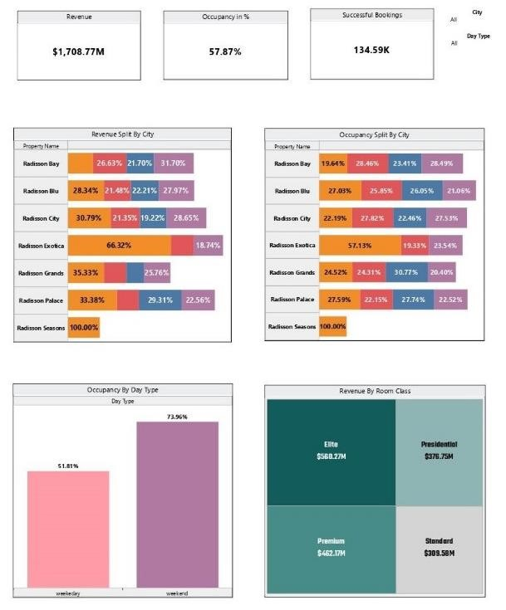

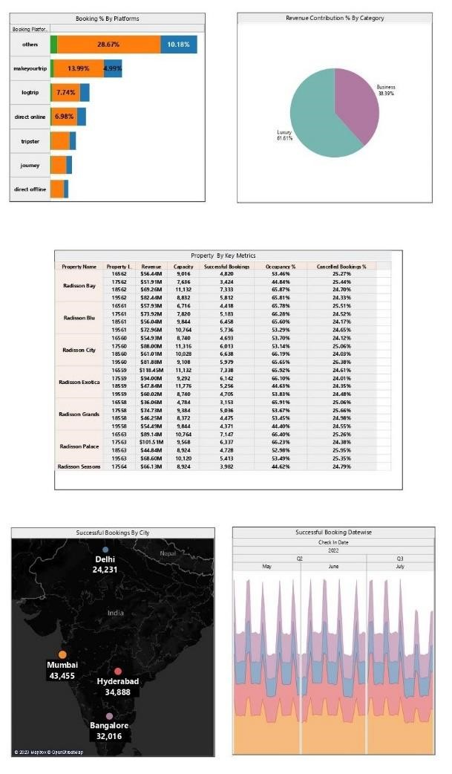

## 3.2 Radisson Analysis Story

A data story is a method of conveying information and analysis in a narrative structure, with the aim of enhancing engagement and comprehension. It usually features a concise introduction that establishes the context and background for the data, a well-organized body that systematically presents the data and analysis, and a conclusion that summarizes the main insights and their significance.

1. Mumbai has made highest number of Successful Bookings 43,455

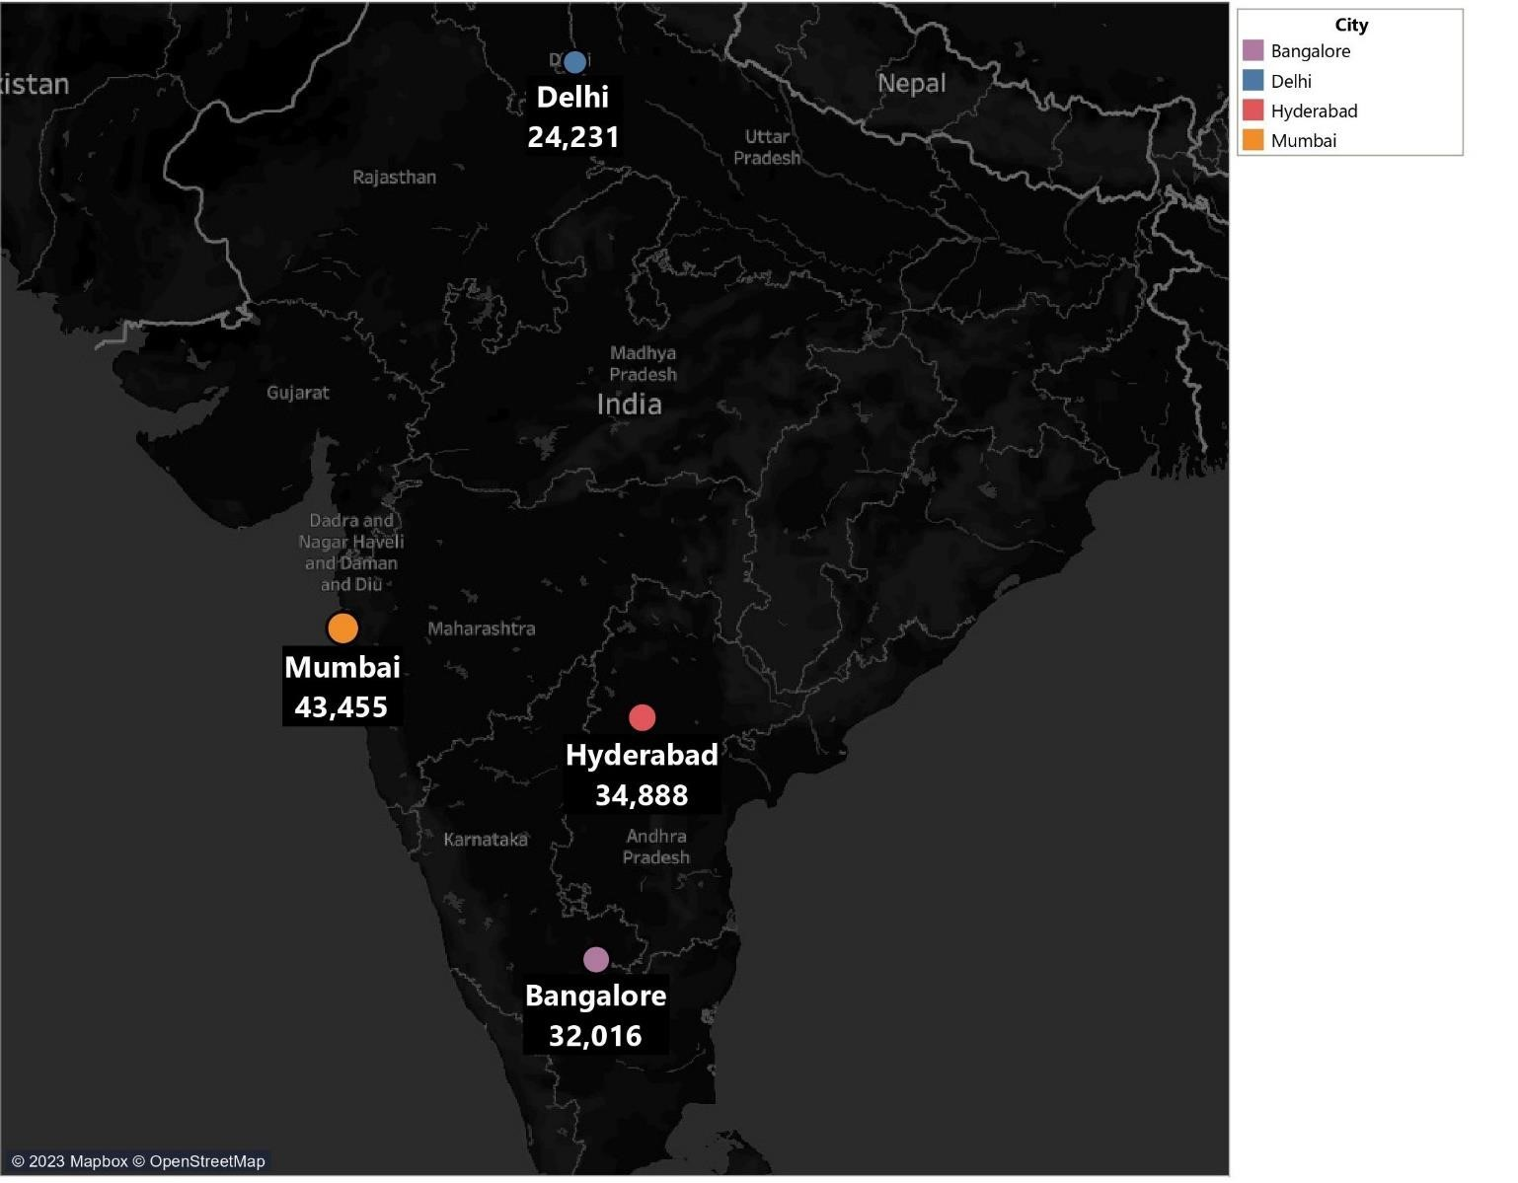

1. Elite and Premium room classes are the top 2 highest revenue contributors

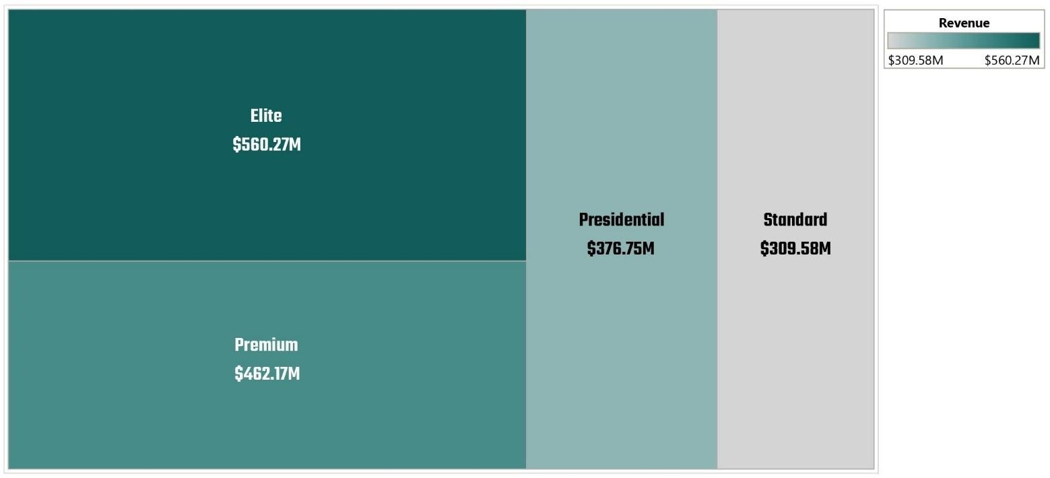

1. Other Platforms and Make your trip contributed 42% of the total checked out bookings

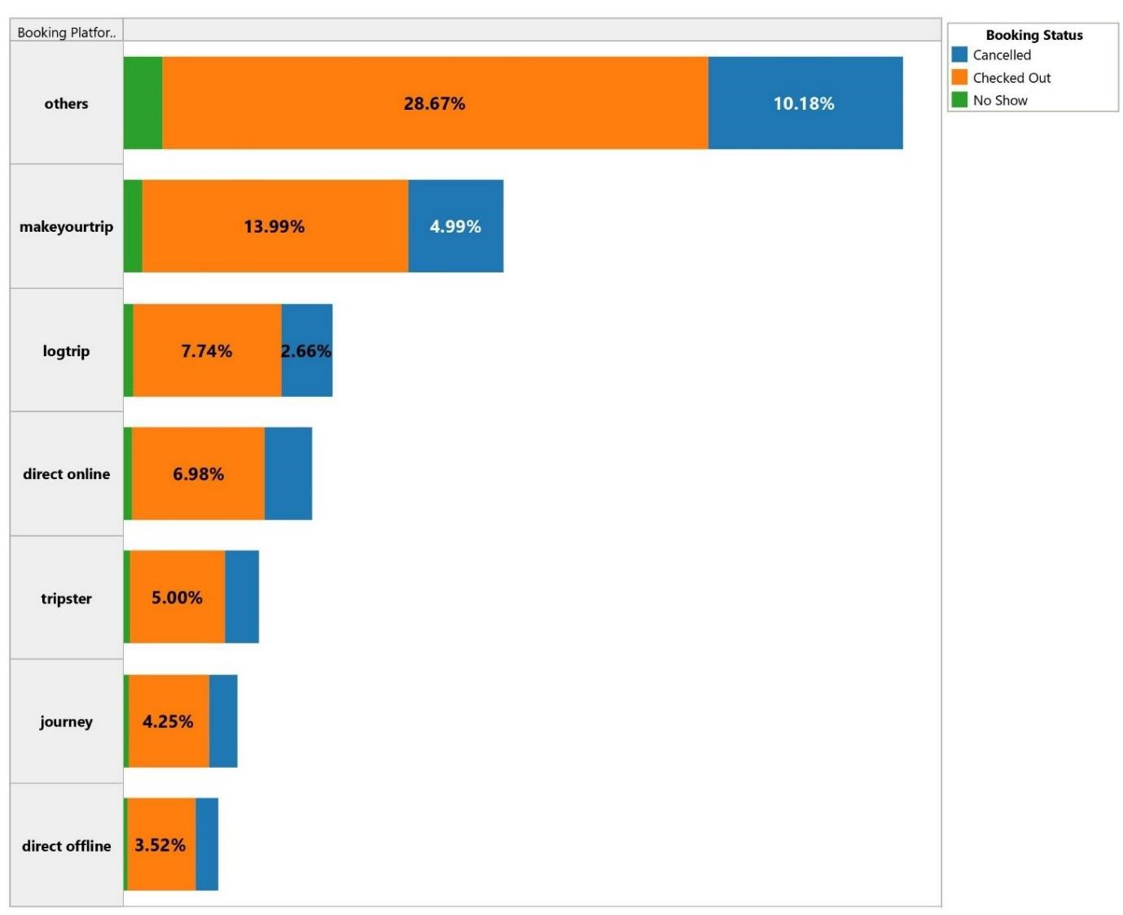

1. All properties have average 25% Cancellation rate and 50% Occupancy rate

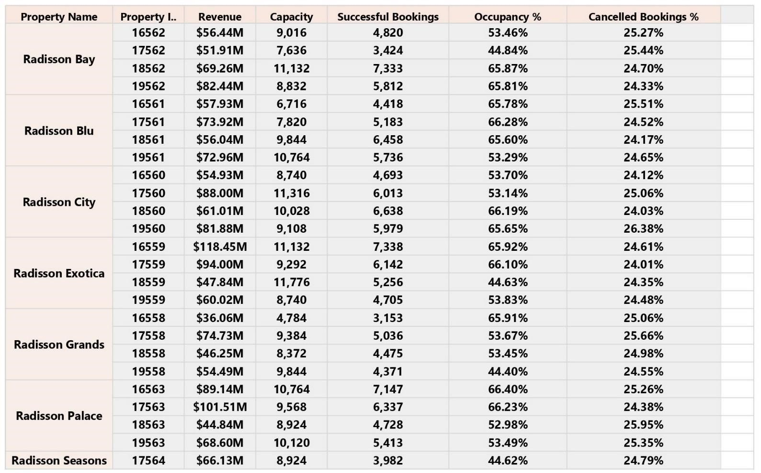

# 4. Advantages & Disadvantages

The project is a evidence of the Data Visualization methods which the decisionmaking process for organizations easier, but we still have few drawbacks. Let's evaluate.

|  |  |
| --- | --- |
| **ADVANTAGES** | **DISADVANTAGES** |
| Easy data processing | Data sets must be detailed |
| Visualizations provide far better info than text or numbers | The visualizations must be accurate & reliable |
| Less creating time & even less studying time for the produced content. | The craft requires precise data sets & handling capabilities of the creator. |
| The tool has enormous capabilities in terms of data modelling | A good expertise on the tool should be achieved. |

# 5. Applications

There are wide variety of application for such a tool like this.

* Business Intelligence
* Data Visualization
* Data Collaboration
* Data Blending
* Real-time data analysis
* Query translation into visualization
* To import large size of data
* To create no-code data queries
* To manage large size metadata

The project provides huge accessibility to opportunities where the applications are limitless using the tool, which is the fastest growing data visualization tool on the market

# 6. Observation

The processing of the data has proven that, there are 3 major influencing factors that affect the variation in the Net worth. The Radisson Hotel can focus on these proceedings to strategically analysis and make key decisions regarding their organization.

* Mumbai has made highest number of Successful Bookings 43,455
* Elite and Premium room classes are the top 2 highest revenue contributors
* Other Platforms and Make your trip contributed 42% of the total checked out bookings
* All properties have average 25% Cancellation rate and 50% Occupancy rate

This analysis will help to improve the guest satisfaction and also help the Radisson Hotels management team to make better business decisions to improve market share and revenue.

# 7. Conclusion

In summary, the development of an analytics dashboard and story has allowed for a comprehensive analysis of Radisson Hotels' performance and efficiency, providing valuable insights for the management team. The identified key performance indicators and metrics, as well as the forecasting models, will assist in making datadriven decisions to improve market share and revenue. The data story has highlighted the top influencing factors, including successful bookings, room classes, and distribution platforms, which will enable the hotels to enhance guest satisfaction and optimize their operations. Overall, the proposed solution will provide Radisson Hotels with a competitive edge in the hospitality industry.

# 8. Future Scope

The use of Data Analytics will yield in selection of better decisions which are good for business. People do not yet understand the potential of this field right now. It is going to be part of every industry ever thrived. The impossible will become possible, and this may well lead to an autonomous decision-making process. Data analytics is expected to radically change the way we live and do business in the future. Already today we use the analytics in our technology devices, for many decisions in our lives. IBM COGNOS is emerging as one of the hottest trends in business intelligence in 2020. The data visualization tool has been gaining popularity in companies big and small, and hence, IBM cognos careers are uber-in. Looking at google trends, it seems there can be no better time than “now” to get certified in IBM cognos and build a career in Business Intelligence and Data Analytics. Apart from its high visualization functionality, users rate its overall performance as robust and reliable. The tool also operates fast even on big data, which makes its powerful performance an important point in the list of the advantages of Tableau. Companies in the future does not have to depend on external data professionals in order to make better decisions for their company. They can process, analyze & enhance data to learn what is good and bad for the organization. The scope is endless.

# 9. Appendix

## 9.1 IBM Cognos Public View

**Dashboard Public Link –**

<https://us1.ca.analytics.ibm.com/bi/?perspective=dashboard&pathRef=.my_folders%2FRadission_hotel%2Bdashboard&action=view&mode=dashboard&subView=model0000018a70c1949e_00000007>

**Story Public Link -**

## <https://us1.ca.analytics.ibm.com/bi/?perspective=story&pathRef=.my_folders%2FRadission_hotel%2Bstory&action=view&sceneId=-1&sceneTime=0>

## 

## 9.2 Source Code

<!DOCTYPE html>

<html lang="en">

<head>

  <meta charset="utf-8">

  <meta content="width=device-width, initial-scale=1.0" name="viewport">

  <title>RADISSON HOTELS | Responsive Travel & Tourism Template</title>

  <meta content="" name="description">

  <meta content="" name="keywords">

  <!-- Favicons -->

  <link href="assets/img/favicon.png" rel="icon">

  <link href="assets/img/apple-touch-icon.png" rel="apple-touch-icon">

  <!-- Google Fonts -->

  <link href="https://fonts.googleapis.com/css?family=Open+Sans:300,300i,400,400i,600,600i,700,700i|Krub:300,300i,400,400i,500,500i,600,600i,700,700i|Poppins:300,300i,400,400i,500,500i,600,600i,700,700i" rel="stylesheet">

  <!-- Vendor CSS Files -->

  <link href="assets/vendor/aos/aos.css" rel="stylesheet">

  <link href="assets/vendor/bootstrap/css/bootstrap.min.css" rel="stylesheet">

  <link href="assets/vendor/bootstrap-icons/bootstrap-icons.css" rel="stylesheet">

  <link href="assets/vendor/boxicons/css/boxicons.min.css" rel="stylesheet">

  <link href="assets/vendor/glightbox/css/glightbox.min.css" rel="stylesheet">

  <link href="assets/vendor/swiper/swiper-bundle.min.css" rel="stylesheet">

  <!-- Template Main CSS File -->

  <link href="assets/css/style.css" rel="stylesheet">

  <!-- =======================================================

  * Template Name: Bikin

  * Updated: Jul 27 2023 with Bootstrap v5.3.1

  * Template URL: https://bootstrapmade.com/bikin-free-simple-landing-page-template/

  * Author: BootstrapMade.com

  * License: https://bootstrapmade.com/license/

  ======================================================== -->

</head>

<body>

  <!-- ======= Header ======= -->

  <header id="header" class="fixed-top">

    <div class="container d-flex align-items-center justify-content-between">

      <h1 class="logo"><a href="index.html"> Radission hotel-make your stay more rewarding</a></h1>

      <!-- Uncomment below if you prefer to use an image logo -->

      <!-- <a href="index.html" class="logo"><img src="assets/img/logo.png" alt="" class="img-fluid"></a>-->

      <nav id="navbar" class="navbar">

        <ul>

          <li><a class="nav-link scrollto active" href="#hero">Home</a></li>

          <li><a class="nav-link scrollto" href="#about">About</a></li>

          <li><a class="nav-link scrollto" href="#dashboard">Dashboard</a></li>

          <li><a class="nav-link scrollto " href="#story">Story</a></li>

          <li><a class="nav-link scrollto" href="#report">Report</a></li>

          <li><a class="nav-link scrollto" href="#contact">Contact</a></li>

        <i class="bi bi-list mobile-nav-toggle"></i>

      </nav><!-- .navbar -->

    </div>

  </header><!-- End Header -->

  <!-- ======= Hero Section ======= -->

  <section id="hero" class="d-flex align-items-center">

    <div class="container d-flex flex-column align-items-center justify-content-center" data-aos="fade-up">

      <h1>Welcome to Radisson Hotels</h1>

      <h2>Explore your favorite destinations in India as we celebrate 25 years of delivering memorable moments</h2>

      <a href="#about" class="btn-get-started scrollto">Get Started</a>

      <img src="https://th.bing.com/th?id=OIP.lsoycdmk7c3OHemDY8OhHwHaE7&w=240&h=160&c=8&rs=1&qlt=90&o=6&dpr=1.3&pid=3.1&rm=2" class="img-fluid hero-img" alt="" data-aos="zoom-in" data-aos-delay="150">

    </div>

  </section><!-- End Hero -->

  <main id="main">

    <!-- ======= About Section ======= -->

    <section id="about" class="features" data-aos="fade-up">

      <div class="container">

        <div class="section-title">

          <h3>About</h3>`

      </div>

      An radission is a website that searches for offers on multiple websites and shows you the results in one place.Explore over 1100 hotels worldwide and book your stay with us today ,with best online services, you’re virtually guaranteed to find a cheaper and best services booking rooms than if you searched manually, and you’ll also save a lot of time doing so.An radission hotel is a website that searches for offers on multiple websites and shows you the leads to one place.you will be able to check multiple radission hotels at once and understand which one is the cheapest and best services.

      </div>

    </section>

    <!-- End Features Section -->

    <!-- End About Section -->

    <!-- ======= Clients Section ======= -->

    <!-- ======= Features Section ======= -->

    <section id="dashboard" class="features" data-aos="fade-up">

      <div class="container">

        <div class="section-title">

          <h3>Dashboard</h3>

      </div>

      <iframe src="https://us1.ca.analytics.ibm.com/bi/?perspective=dashboard&amp;pathRef=.my_folders%2FRadission_hotel%2Bdashboard&amp;closeWindowOnLastView=true&amp;ui_appbar=false&amp;ui_navbar=false&amp;shareMode=embedded&amp;action=view&amp;mode=dashboard&amp;subView=model0000018a70c1949e_00000007" width="1800" height="900" frameborder="0" gesture="media" allow="encrypted-media" allowfullscreen=""></iframe>"></iframe>"></iframe>

      </div>

    </section>

    <!-- End Features Section -->

    <!-- ======= Services Section ======= -->

    <section id="story" class="services">

      <div class="container" data-aos="fade-up">

        <div class="section-title">

          <h2>Story</h2>

        </div>

        <iframe src="https://us1.ca.analytics.ibm.com/bi/?perspective=story&amp;pathRef=.my_folders%2FRadission_hotel%2Bstory&amp;closeWindowOnLastView=true&amp;ui_appbar=false&amp;ui_navbar=false&amp;shareMode=embedded&amp;action=view&amp;sceneId=-1&amp;sceneTime=0" width="1800" height="900" frameborder="0" gesture="media" allow="encrypted-media" allowfullscreen=""></iframe>

<!-- End Services Section -->

    <!-- ======= Portfolio Section ======= -->

    <section id="report" class="portfolio">

      <div class="container" data-aos="fade-up">

        <div class="section-title">

          <h2>Report</h2>

        </div>

        <iframe src="https://us1.ca.analytics.ibm.com/bi/?pathRef=.my_folders%2FRadission_hotel%2Breport&amp;closeWindowOnLastView=true&amp;ui_appbar=false&amp;ui_navbar=false&amp;shareMode=embedded&amp;action=run&amp;format=HTML&amp;prompt=false" width="1800" height="900" frameborder="0" gesture="media" allow="encrypted-media" allowfullscreen=""></iframe>

        </div>

    </section><!-- End Portfolio Section -->

    <!-- ======= Testimonials Section ======= -->

    <!-- End Testimonials Section -->

    <!-- ======= Team Section ======= -->

    <!-- ======= Contact Section ======= -->

    <section id="contact" class="contact section-bg">

      <div class="container" data-aos="fade-up">

        <div class="section-title">

          <h2>Contact</h2>

          <p>Magnam dolores commodi suscipit. Necessitatibus eius consequatur ex aliquid fuga eum quidem. Sit sint consectetur velit. Quisquam quos quisquam cupiditate. Et nemo qui impedit suscipit alias ea. Quia fugiat sit in iste officiis commodi quidem hic quas.</p>

        </div>

        <div class="row">

          <div class="col-lg-6">

            <div class="row">

              <div class="col-md-12">

                <div class="info-box">

                  <i class="bx bx-map"></i>

                  <h3>Our Address</h3>

                  <p>A108 Adam Street, india, in 535022</p>

                </div>

              </div>

              <div class="col-md-6">

                <div class="info-box mt-4">

                  <i class="bx bx-envelope"></i>

                  <h3>Email Us</h3>

                  <p>info@example.com<br>contact@example.com</p>

                </div>

              </div>

              <div class="col-md-6">

                <div class="info-box mt-4">

                  <i class="bx bx-phone-call"></i>

                  <h3>Call Us</h3>

                  <p>+91  5589 55488 55<br>+91 6678 254445 41</p>

                </div>

              </div>

            </div>

          </div>

          <div class="col-lg-6 mt-4 mt-md-0">

            <form action="forms/contact.php" method="post" role="form" class="php-email-form">

              <div class="row">

                <div class="col-md-6 form-group">

                  <input type="text" name="name" class="form-control" id="name" placeholder="Your Name" required>

                </div>

                <div class="col-md-6 form-group mt-3 mt-md-0">

                  <input type="email" class="form-control" name="email" id="email" placeholder="Your Email" required>

                </div>

              </div>

              <div class="form-group mt-3">

                <input type="text" class="form-control" name="subject" id="subject" placeholder="Subject" required>

              </div>

              <div class="form-group mt-3">

                <textarea class="form-control" name="message" rows="5" placeholder="Message" required></textarea>

              </div>

              <div class="my-3">

                <div class="loading">Loading</div>

                <div class="error-message"></div>

                <div class="sent-message">Your message has been sent. Thank you!</div>

              </div>

              <div class="text-center"><button type="submit">Send Message</button></div>

            </form>

          </div>

        </div>

      </div>

    </section><!-- End Contact Section -->

  </main><!-- End #main -->

  <!-- ======= Footer ======= -->

  <footer id="footer">

    <div class="footer-top">

      <div class="container">

        <div class="row">

          <div class="col-lg-3 col-md-6 footer-contact">

            <h3>radission hotel</h3>

            <p>

              A108 Adam Street <br>

              india, in  515022<br>

              india <br><br>

              <strong>Phone:</strong> +915589 55488 55<br>

              <strong>Email:</strong> info@example.com<br>

            </p>

          </div>

          <div class="col-lg-2 col-md-6 footer-links">

            <h4>Useful Links</h4>

            <ul>

              <li><i class="bx bx-chevron-right"></i> <a href="#">Home</a></li>

              <li><i class="bx bx-chevron-right"></i> <a href="#">About us</a></li>

              <li><i class="bx bx-chevron-right"></i> <a href="#">Services</a></li>

              <li><i class="bx bx-chevron-right"></i> <a href="#">Terms of service</a></li>

              <li><i class="bx bx-chevron-right"></i> <a href="#">Privacy policy</a></li>

            </ul>

          </div>

          <div class="col-lg-3 col-md-6 footer-links">

            <h4>Our Services</h4>

            <ul>

              <li><i class="bx bx-chevron-right"></i> <a href="#">Web Design</a></li>

              <li><i class="bx bx-chevron-right"></i> <a href="#">Web Development</a></li>

              <li><i class="bx bx-chevron-right"></i> <a href="#">Product Management</a></li>

              <li><i class="bx bx-chevron-right"></i> <a href="#">Marketing</a></li>

              <li><i class="bx bx-chevron-right"></i> <a href="#">Graphic Design</a></li>

            </ul>

          </div>

          <div class="col-lg-4 col-md-6 footer-newsletter">

            <h4>Join Our Newsletter</h4>

            <p>Tamen quem nulla quae legam multos aute sint culpa legam noster magna</p>

            <form action="" method="post">

              <input type="email" name="email"><input type="submit" value="Subscribe">

            </form>

          </div>

        </div>

      </div>

    </div>

    <div class="container d-md-flex py-4">

      <div class="me-md-auto text-center text-md-start">

        <div class="copyright">

          &copy; Copyright <strong><span>Bikin</span></strong>. All Rights Reserved

        </div>

        <div class="credits">

          <!-- All the links in the footer should remain intact. -->

          <!-- You can delete the links only if you purchased the pro version. -->

          <!-- Licensing information: https://bootstrapmade.com/license/ -->

          <!-- Purchase the pro version with working PHP/AJAX contact form: https://bootstrapmade.com/bikin-free-simple-landing-page-template/ -->

          Designed by <a href="https://bootstrapmade.com/">BootstrapMade</a>

        </div>

      </div>

      <div class="social-links text-center text-md-right pt-3 pt-md-0">

        <a href="#" class="twitter"><i class="bx bxl-twitter"></i></a>

        <a href="#" class="facebook"><i class="bx bxl-facebook"></i></a>

        <a href="#" class="instagram"><i class="bx bxl-instagram"></i></a>

        <a href="#" class="google-plus"><i class="bx bxl-skype"></i></a>

        <a href="#" class="linkedin"><i class="bx bxl-linkedin"></i></a>

      </div>

    </div>

  </footer><!-- End Footer -->

  <div id="preloader"></div>

  <a href="#" class="back-to-top d-flex align-items-center justify-content-center"><i class="bi bi-arrow-up-short"></i></a>

  <!-- Vendor JS Files -->

  <script src="assets/vendor/aos/aos.js"></script>

  <script src="assets/vendor/bootstrap/js/bootstrap.bundle.min.js"></script>

  <script src="assets/vendor/glightbox/js/glightbox.min.js"></script>

  <script src="assets/vendor/isotope-layout/isotope.pkgd.min.js"></script>

  <script src="assets/vendor/swiper/swiper-bundle.min.js"></script>

  <script src="assets/vendor/php-email-form/validate.js"></script>

  <!-- Template Main JS File -->

  <script src="assets/js/main.js"></script>

</body>

</html>